Part I Directions:
Follow the trails of Heart and Arms. Fill in the chart below.

 | Heart   | Arms  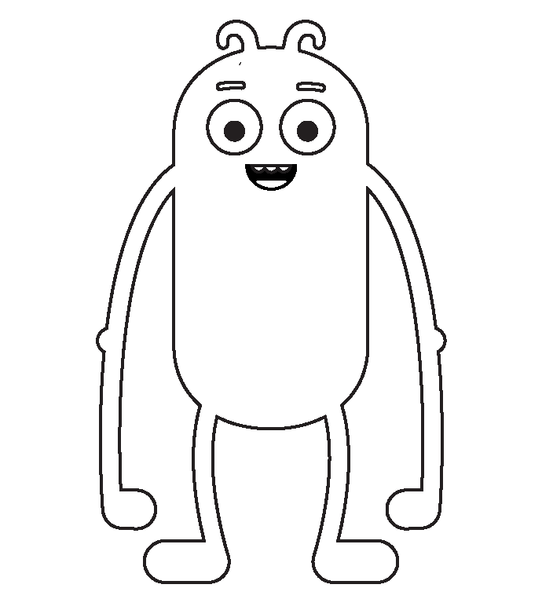
1. Whose full name do you know?
2. Whose house could you find?
3. Whose birth date do you know?
4. Whose username and password do you know?
5. Who let out a secret on the internet?
6. Whose pet do you know?

1. Who can the detectives find out more about, and why?

2. Is there anything that Heart or Arms posted that could be a problem for them?

Pause & Think Moment
Draw a picture of something that is OK to share about yourself on the internet.

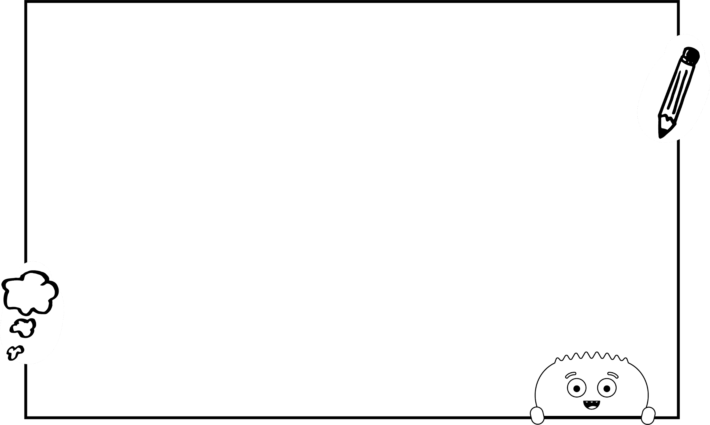

Write one thing that is not OK to share on the internet. Explain why.

